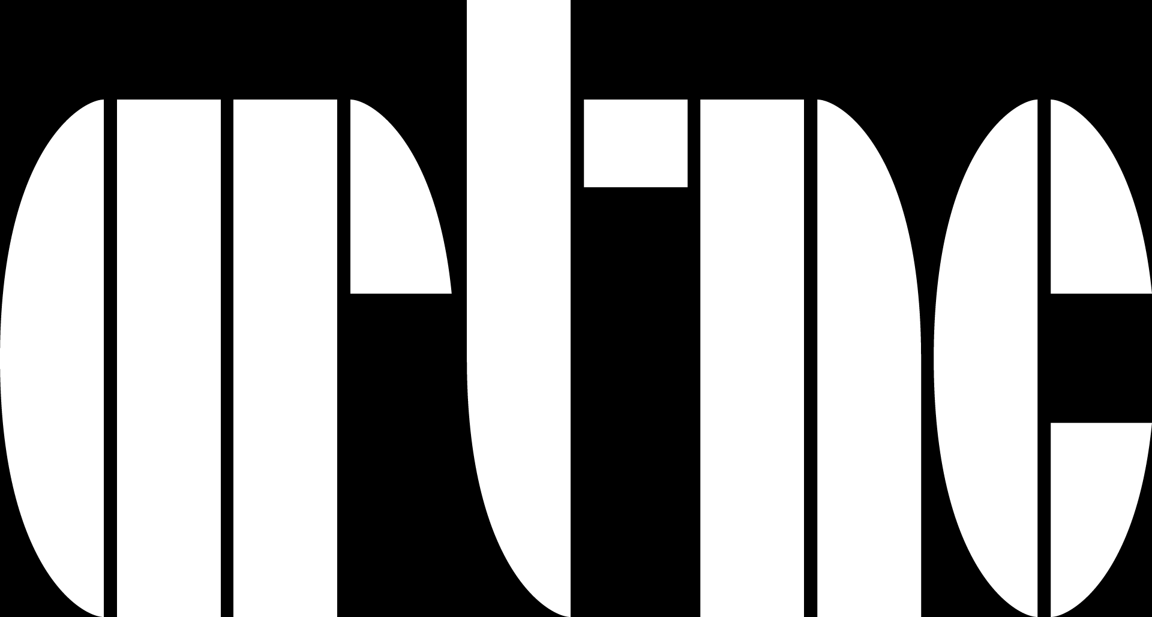
www.artnc.org

Reading Art: Picturing Text

Writer: Carolyn Walker, English Language Arts Teacher
Grade Level: 3–5
Related Big Picture Concepts: Meaning, Communication
Subject Areas: Art, Language Arts, Social Studies
Duration: 5–6 class periods of 45 minutes
Essential Question: How can meaning be communicated symbolically?

Abstract: Through observation and discussion about the Inner Coffin of Djedmut, students will make connections between hieroglyphs and the English writing system. They will learn how visual images can be used to communicate sounds and meaning. As a class, students will compose a story about change in their community or state using pictograms of their own design.

Focus Works of Art:
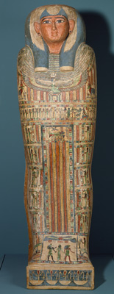
Egyptian
Inner Coffin of Djed Mut, circa 715-525 B.C.E.
Wood with linen, gesso, and paint
H. 71 in. (180.3 cm)

North Carolina Standards Correlations
Visual Arts:
3.V.1.2, 3.V.2.1, 3.V.3.3, 3.CX.1.2, 3.CX.1.4, 3.CX.2.3
4.V.1.3, 4.V.2.1, 4.V.3.3, 4.CX.1.4, 4.CX.2.3
5.V.2.1, 5.V.3.3, 5.CX.1.4, 5.CX.2.3

Language Arts:
3.W.4, 3.SL.1
4.W.4, 4.SL.1
5.W.4, 5.SL.1

Social Studies:
3.H.1.1
4.H.2.1

Student Learning Objectives
- Students will discuss how artists convey meaning by studying an Egyptian mummy case, gaining understanding of how symbols are used.
- Students will explore working with symbols, both individually and as part of a class art project.
- Students will investigate how a selected aspect of the community or state has changed over time.
- Students will explain new understandings, both symbolically as part of the art project and individually through journal writing.

Activities
1. As a class, explore the Inner Coffin of Djedmut using a KWL chart. Read a chapter from Eloise McGraw's The Golden Goblet or Ancient Egypt (Eyewitness Books) to help answer their questions. As a class, discuss findings. Ask:

What type of imagery did you see on the mummy case? (human figures, hieroglyphs, and animals)
How has that imagery been organized? (in horizontal rows and vertical columns)
Which areas seem to be the most important parts of the imagery?
How does the artist tell you that?
What does that say about this community?
What do you think the imagery in those areas tells us? How does an artist express ideas?
How is this art similar to or different from art created today?

2. Give the students some information on the mummy case and Egyptian hieroglyphs. Explain that this type of writing is made up of pictograms, or pictures that represent words, sounds, or ideas. Ask students to think of some pictograms that we use in our culture.

Ask:
How is the English alphabet different from Egyptian hieroglyphs? How is it similar?
How is writing a letter of the alphabet like drawing a picture? (we use our hands and a writing tool; it takes practice; we all have our own style of handwriting)
How is a letter of the alphabet different from a picture? (it represents a sound, not an object)

3. Have students (individually or in groups) create a rebus, a picture puzzle that can be sounded out by reading the sounds symbolized by the picture. Give the students the rebus as a model. Have students swap their completed rebuses with a partner or another group and try to decode the visual images. Discuss the process of writing and reading a phrase using pictures, rather than letters. Ask:

Did you find it was easier or harder to communicate using pictures instead of text? Why?
What are the advantages of each type of communication?

4. Tell students they are going to create a mural about their community using pictograms. As a class, choose a historic place in the town or community that has changed over time. For fourth grade, choose a significant place in the state. Ask students to consider what they want people to know about the place. What is the message you want to communicate? To jump-start the conversation, have them consider:

What goes on in this place? What is its function?
What types of people do you find there?
How has this place changed over time?
What impact have individuals had on this place?
Why is this important?
How does this express the history of our community/state?

5. Create a chart that lists these answers and any other ideas that come to the students' minds. As a class, decide how this information should be organized so that readers/viewers will understand the message. As an aid, create a storyboard that puts this information in order. Encourage discussion of how to problem solve and consider multiple solutions when creating original art.

6. Assign a portion of the story to each student or to several small groups of students. Instruct them to create a visual symbol that communicates the portion of the story they have been given. Students may need to do some research to determine if symbols already exist for this information. They may choose to use those existing symbols or create their own.

After students decide upon the imagery they will use, give the individual students or groups each a different colored piece of 11 x 17" construction paper. Instruct student to design their symbol on this paper using a variety of art supplies (markers, crayons, paints, etc.). Once students have finished, refer back to the storyboard to determine how to order the symbols. Number each piece of construction paper according to its place in the story.

Arrange the symbols in their assigned order in horizontal bands against a blank wall or hallway. Use pieces of black 11 x 17" construction paper as spacers between symbols, if needed.

(For a larger mural, scan the construction paper symbols to create transparencies of the art. Project the transparencies onto larger pieces of foam core or Masonite. Have students trace the image onto the larger background and paint their larger design. Arrange the symbols in their assigned order in horizontal bands against a blank wall or hallway.)

7. Have students in another class "read" the visual story and write a brief summary of what they think it communicates. Compare these stories and discuss how well the symbols communicated the desired message. Consider alterations or improvements to the story. Refine as needed, and leave the finished result on display. Invite members of the community being depicted to the school to see the pictogram story.

8. Have students write a reflective journal about their contribution to the mural and how they felt about working as a team. Model clear, coherent writing. Confer with students to aid understanding of development and organization of ideas.

Assessments

- Evaluate discussion for student understanding of how artists use art to express ideas, how to infer meaning from art, how traditions, values, time, and place influence art.
- Observe student interactions to evaluate collaborative skills in creating a class piece of art.
- Evaluate rebus projects and pictograms to assess for understanding of how symbols convey meaning.
- Assess reflective journal using local rubrics for clear, coherent writing, with development and organization appropriate to task, purpose, and audience.
- Evaluate discussion using local rubrics for student participation including; following rules for discussion, building upon others’ ideas, and asking questions.
- Evaluate discussion, writing, and art for understanding of key historical places in the community or state.

Resources
Vocabulary:
hieroglyph
ideogram
mummy
pictogram
phonogram
rebus
register
symbol

Materials:
11 x 17" construction paper, markers, crayons, paints, etc.

Links:
KWL Charts
http://www.abcteach.com/directory/researchreports/graphic_organizers/

Evolution of Type (Pictograms, Ideograms, Phonograms)
http://www.mediumbold.com/04_thinking/type/origins/index.html
Hieroglyphs

Nova: Hieroglyphs
http://www.pbs.org/wgbh/nova/pyramid/hieroglyph/hieroglyph4.html

PBS: Pictures as Words
http://pbskids.org/sagwa/games/picturesaswords/

Sample Rebus
http://www.fun-with-words.com/rebus_puzzle_explain.html

